ELEMENTARY SCHOOL MEALS PROGRAM
LUNCH ORDER FORM

School’s Name:
Student’s Name:
Grade:
Division:
Teacher:

Allergies / Religious Requests: _____________________________________

Payment Amount: _______________



APRIL 2016

MONDAY | TUESDAY | WEDNESDAY | THURSDAY | FRIDAY
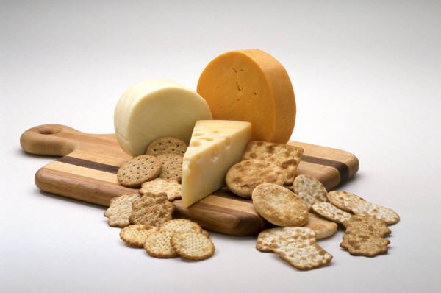 | 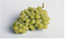 | 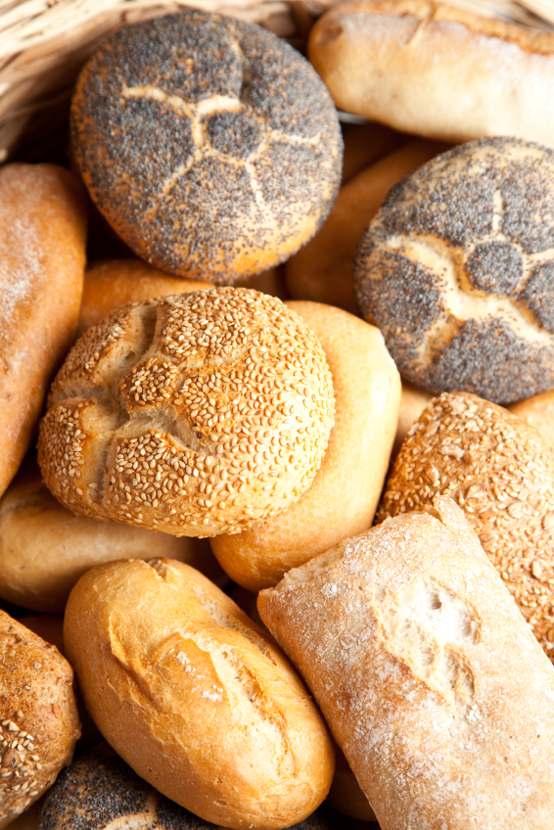 |  | 1  Chocolate Milk  Roast Beef Sandwich  Bits & Bites  Fruit
4  Juice  Turkey Sandwich  Yogurt  Fruit | 5  White Milk  Ham Sandwich  Chips  Fruit | 6  Juice  Chicken Wrap  Yogurt  Fruit | 7  Chocolate Milk  Roast Beef Sandwich  Pudding  Veggies & Dip | 8  Juice  Egg Sandwich  Granola Bar  Yogurt
11  White Milk  Cheese Sandwich  Cookie  Fruit | 12  Juice  Turkey Sandwich  Pudding  Fruit | 13  Chocolate Milk  Roast Beef Sandwich  Rice Krispie Square  Fruit | 14  Juice  Salsa, Chips & Cheese  Veggies & Dip  Yogurt | 15  DISTRICT  NON-INSTRUCTIONAL DAY
18  White Milk  Cheese Sandwich  Cookie  Fruit | 19  Juice  Roast Beef Sandwich  Yogurt  Fruit | 20  Chocolate Milk  Chicken Wrap  Snack  Fruit | 21  Juice  Egg Sandwich  Veggies & Dip  Yogurt | 22  White Milk  Turkey Sandwich  Trail Mix  Fruit
25  Juice  Roast Beef Sandwich  Yogurt  Fruit | 26  Chocolate Milk  Ham Sandwich  Cookie  Fruit | 27  Juice  Tuna & Crackers  Pudding  Fruit | 28  White Milk  Turkey Sandwich  Granola Bar  Fruit | 29  Juice  Cheese Sandwich  Yogurt  Veggies & Dip

PLEASE NOTE:

- WE DO NOT GUARANTEE A NUT-FREE ENVIRONMENT. ALL OF OUR BREADS AND BAKED GOODS MAY CONTAIN TRACES OF NUTS.

- MENU SUBJECT TO CHANGE BASED ON AVAILABILITY FROM SUPPLIERS.

- April Lunches: 20 @ $4.00 = $80.00
- Please make cheque payable to the school.

- ORDERS DUE TO OFFICE BY 9:00 AM, WEDNESDAY, MARCH 9, 2016. SORRY, LATE ORDERS WILL NOT BE ACCEPTED.

